Terraform init

Comando para crear los plugis que permitirán interactuar con AWS

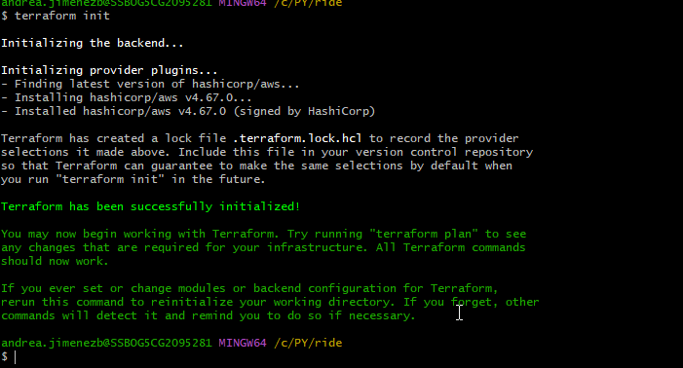

Primer error:  
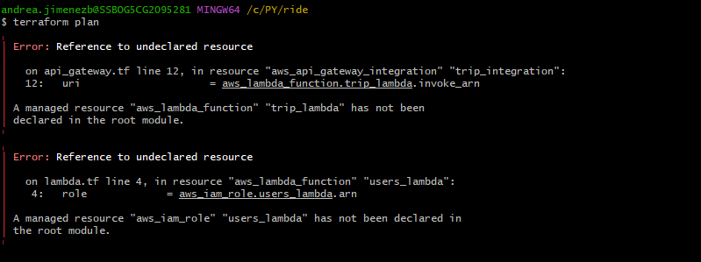

Siguiente error:

Solo un error:

Terraform apply

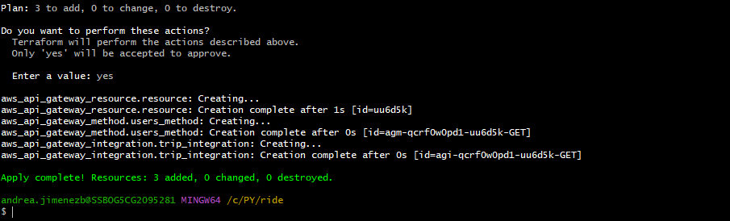

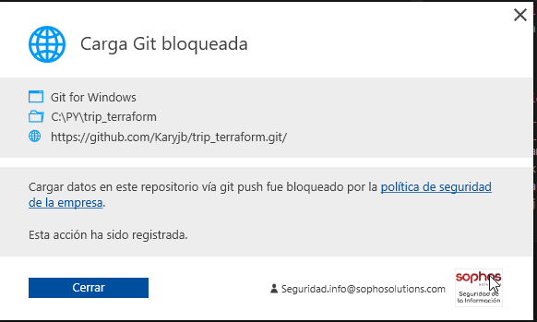

pm ERR! code 128

npm ERR! An unknown git error occurred

npm ERR! command git --no-replace-objects ls-remote ssh://git@github.com/aws-sdk/client-dynamodb.git

npm ERR! Warning: Permanently added 'github.com' (ED25519) to the list of known hosts.

npm ERR! git@github.com: Permission denied (publickey).

npm ERR! fatal: Could not read from remote repository.

npm ERR!

npm ERR! Please make sure you have the correct access rights

npm ERR! and the repository exists.

npm ERR! A complete log of this run can be found in:

npm ERR! C:\Users\andrea.jimenezb\AppData\Local\npm-cache\_logs\2023-05-25T00_59_48_764Z-debug-0.log

#### Estudiar que es ES module y CommonJS

#### Error: undefined ERROR Uncaught Exception {"errorType":"ReferenceError","errorMessage":"require is not defined in ES module scope, you can use import instead\nThis file is being treated as an ES module because it has a '.js' file extension and '/var/task/package.json' contains \"type\": \"module\". To treat it as a CommonJS script, rename it to use the '.cjs' file extension."

https://repost.aws/questions/QU9hDBbz8OTSWY53n5rdL7Wg/referenceerror-require-is-not-defined-in-es-module-scope-you-can-use-import-instead

andrea.jimenezb@SSBOG5CG2095281 MINGW64 /c/PY/trip-user-lambda

$ npm i aws-sdk --save

npm WARN deprecated querystring@0.2.0: The querystring API is considered Legacy. new code should use the URLSearchParams API instead.

added 31 packages, and audited 32 packages in 7s

13 packages are looking for funding

run `npm fund` for details

found 0 vulnerabilities

Hash trabaja con los hash.

Funciones síncronas y asíncronas

Códigos http: 200 -todo

500 – no found server

400 – error usuarios -bad request

No tipado –

Heders

REACT.

REST que es?  
clases abstractas – interfases diferencia

Programación orientada a objetos

Sql básico. (DDL, DML y DCL).

Probar: <https://www.hackerrank.com/>  
Home work

**Síncrono:** El código no puede continuar hasta tener una respuesta.

**asíncrono:** puede continuar ejecutando otras partes del código hasta que tenga una respuesta.

Perfil Desarrollador:  
in addition, I have to plan and develop the special requests such as angular applications, JavaScript within AJAX framework and SQL queries. Since 2020 I have been developing a tool using Java with Spring Boot deployed with React as frontend; whose objective is to manage and assign the work of the support staff within Kanban methodology. Moreover, through this process, I have been using GitHub in order to control versions and Junit for testing.